Name:VAMSI GORANTLA

REG:192110639.

C++ LAB PROGRAMS:

1.age eligible for voting.

Code:

#include<iostream>

using namespace std;

int main()

{

int age;

cin>>age;

if(age>=18)

{cout<<"eligible";}

else

{cout<<"not";}

}

Output:

18

eligible

--------------------------------

Process exited after 22.13 seconds with return value 0

Press any key to continue . . .

2.switch case:

Code:

#include<iostream>

using namespace std;

float r;

{

cout<<"enter radius";

}

cin>>r;

int exp;

cout>>"enter choice(1)";

cin>>exp;

switch(exp)

{

case 1:

{

cout<<"area of circle"<<3.14*r*r;

break;

}

case 2:

{

cout<<"circumference of circle"<<2*3.14*r;

break;

}

default:

{

cout<<"enter corret radius value";

break;

}

}

}

Output:

enter radius6

31

3.even or odd number

Code:

#include<iostream>

using namespace std;

int main()

{

int a;

cin>>a;

if(a%2==0)

{

cout<<"even";

}

else

{

cout<<"odd";

}

}

Output:

6

Even

4.sub two num?

#include<iostream>

Using namespace std;

Main()

{

cout<<"enter x,y values";

cin>>x>>y;

sub=x-y;

cout<<"sub:"<<sub;

}

Output:

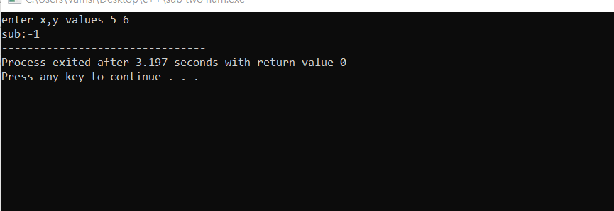

5.div two num?

Prog:

#include<iostream>

using namespace std;

main()

{

int x,y,z;

cout<<"enter x,y values";

cin>>x>>y;

z=x/y;

cout<<z;

}

Output:

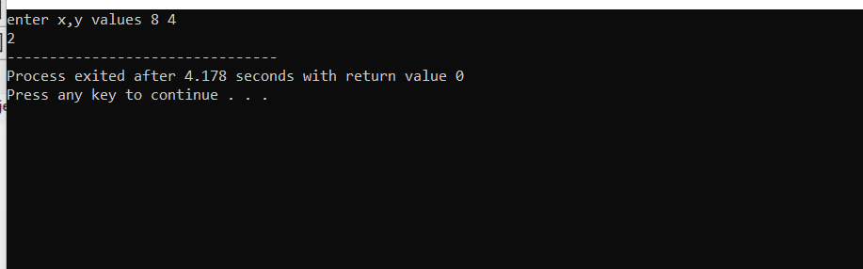

6.mul two num?

Prog:

#include<iostream>

using namespace std;

main()

{

int x,y,z;

cout<<"enter x,y values";

cin>>x>>y;

z=x*y;

cout<<z;

}

Output:

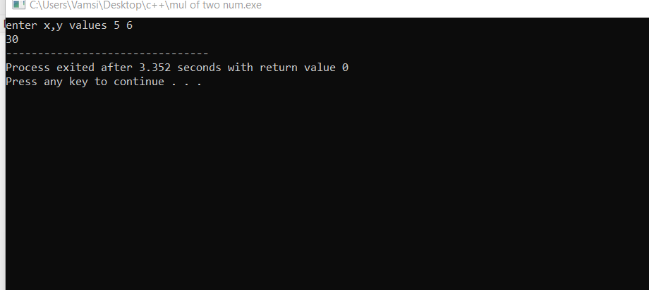

7.c++ for student report?

Prog:

#include<iostream>

using namespace std;

main()

{

int reg_no,m1,m2,m3,total;

float avg;

char name[30];

cout<<"enterr reg_no,m1,m2,m3";

cin>>reg_no>>m1>>m2>>m3;

cout<<"enter name";

cin>>name;

total=m1+m2+m3;

cout<<"total:"<<total;

if(m1>=50&&m1<=100 && m2>=50&&m2<=100 && m3>50&&m3<=100)

avg=total/3;

cout<<"avg:"<<avg;

if(avg>=90)

cout<<"enter s grade";

else if(avg>80 && avg<90)

cout<<"a grade";

else if(avg>70 && avg<80)

cout<<"enter b grade";

else if(avg>60 && avg<70)

cout<<"enter c grade";

else

cout<<"no grade";

}

Output:

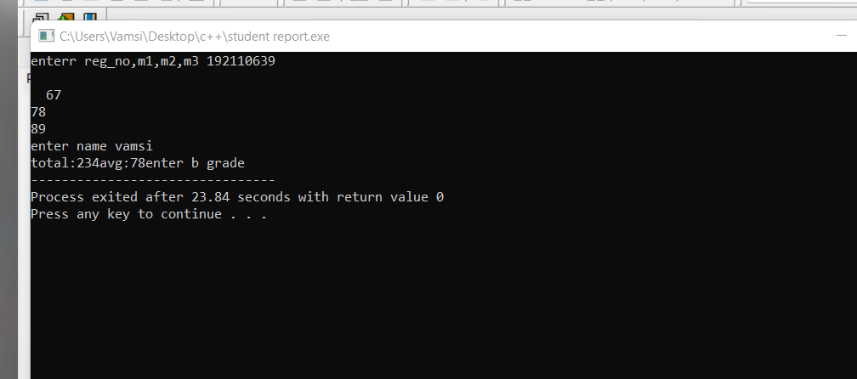

8.c++ add two num using class?

Prog:

#include<iostream>

using namespace std;

class balayya

{

int x,y,sum;

public:

void getdata();

void putdata();

};

void balayya::getdata()

{

cout<<"enter x,y values";

cin>>x>>y;

}

void balayya::putdata()

{

sum=x+y;

cout<<"sum of two num:"<<x+y;

}

main()

{

balayya l;

l.getdata();

l.putdata();

}

Output:

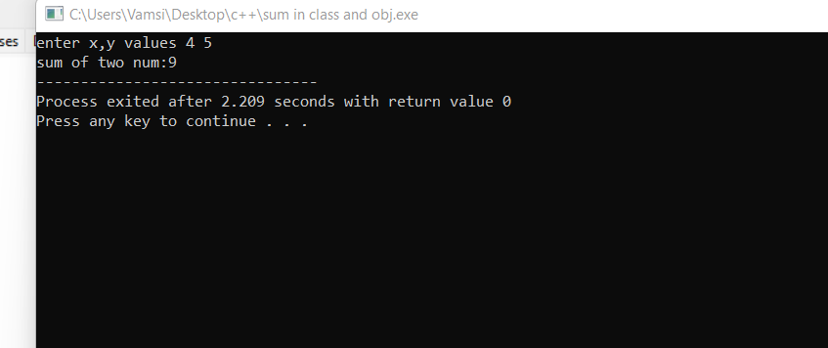

9.c++ big of three num?

Prog:

#include<iostream>

using namespace std;

class biggest

{

int x,y,z;

public:

void getdata();

void putdata();

};

void biggest::getdata()

{

cout<<"enter x,y,z values";

cin>>x>>y>>z;

}

void biggest::putdata()

{

if(x>y && x>z)

cout<<" x is greatest:"<<x;

else if(y>z)

cout<<"y is greatest:"<<y;

else

cout<<"z is greatest:"<<z;

}

main()

{

biggest k;

k.getdata();

k.putdata();

}

Output:

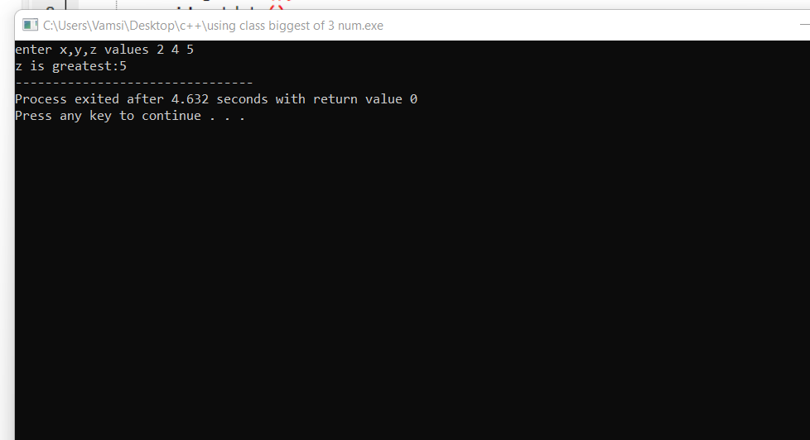

10.c++ for student report in class and obj?

Prog:

#include<iostream>

using namespace std;

class report

{

int reg_no,m1,m2,m3,total;

float avg;

char name[30];

public:

void getdata();

};

void report::getdata()

{

cout<<"enter name";

cin>>name;

cout<<"enetr reg_no";

cin>>reg_no;

cout<<"enter m1 marks";

cin>>m1;

cout<<"enter m2 marks";

cin>>m2;

cout<<"enter m3 marks";

cin>>m3;

total=m1+m2+m3;

cout<<"total:"<<total;

if(m1>=50 && m1<=100 && m2<=50 && m2>=100 && m3<=50 && m3>=100)

avg=total/3;

cout<<"avg:"<<avg;

if(avg>=90)

cout<<"s grade";

else if(avg>=80 && avg<90)

cout<<"a grade";

else if(avg>=70 && avg<80)

cout<<"b grade";

else

cout<<"no grade";

}

main()

{

report h;

h.getdata();

}

Output:

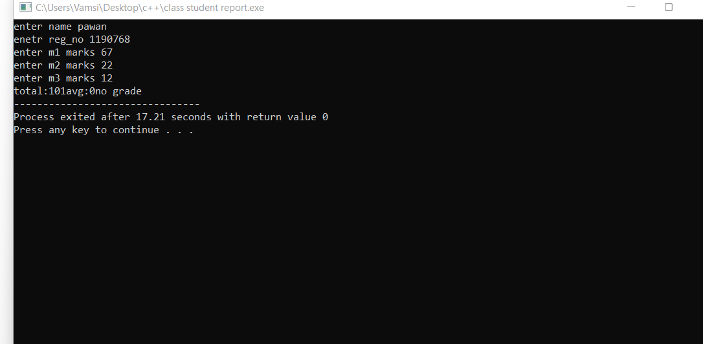

12.c++ oper for arthematic operation using switch case?

Prog:

#include<iostream>

using namespace std;

class arthematic

{

int x,y,choice;

public:

void getdata();

void putdata();

};

void arthematic::getdata()

{

cout<<"enter x,y values";

cin>>x>>y;

}

void arthematic::putdata()

{

cout<<"enter choice";

cin>>choice;

switch(choice)

{

case 1:

cout<<"sum of x,y values:"<<x+y;

break;

case 2:

cout<<"sub x,y values:"<<x-y;

break;

case 3:

cout<<"mul of x,y values:"<<x*y;

break;

default:

cout<<"div of x,y values:"<<x/y;

}

}

main()

{

arthematic k;

k.getdata();

k.putdata();

}

Output:

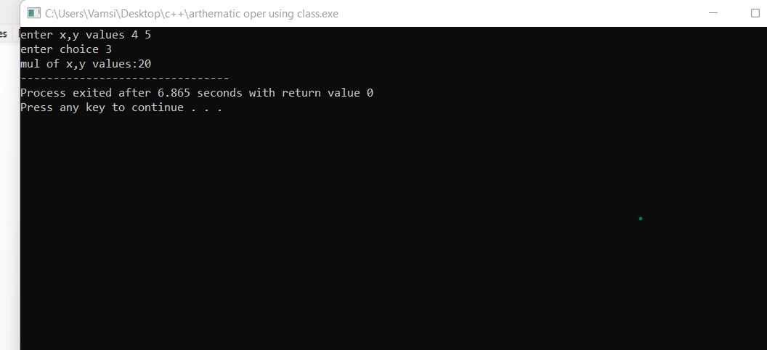

13.c++ program for function overloading?

Prog:

#include<iostream>

using namespace std;

class go

{

int a,b,e,c;

float d,f;

public:

void getdata();

void putdata();

};

void go::getdata()

{

cout<<"enter a,b,e values";

cin>>a>>b>>e;

cout<<"enter d value";

cin>>d;

}

void go::putdata()

{

void sum(int a,int b);

{

int c=a+b;

cout<<c<<endl;

}

void sum(float d,int e);

{

float f=d+e;

cout<<f;

}

}

main()

{

go k;

k.getdata();

k.putdata();

}

Output:

